What would it take to convince you?

Bayesian updating using posteriors from a meta-analysis of published literature as priors for a Registered Replication Report

Ian Hussey & Sean Hughes

Bayesian analysis – the updating of beliefs in light of data – has received increased attention in recent years. However, researchers are divided about whether the integration of individual beliefs into analytic models represents a net strength or weakness of the Bayesian approach. Frequently, even Bayes-curious researchers can struggle with the question of how to select priors. This article presents Registered Replication Reports as a good candidate for the easy selection of priors for Bayesian updating of beliefs.

Bayesian analysis – the updating of beliefs in light of data – has received increased attention in recent years. However, researchers are divided about whether the integration of individual beliefs into analytic models represents a net strength or weakness of the Bayesian approach. Frequently, even Bayes-curious researchers can struggle with the question of how to select priors. This article presents Registered Replication Reports as a good candidate for the easy selection of priors for Bayesian updating of beliefs.

Recently, Moran et al. conducted a RRR of Olson and Fazio’s ‘surveillance task effect’. This effect claims to test the ‘unaware evaluative conditioning’ hypothesis.

While Moran et al employed a frequentist approach in their analyses, it is notable that they presented the results of a meta-analysis of the surveillance task effect literature in their introduction justifying the RRR. As such, Moran et al provide information about both a) prior beliefs in the extant literature and b) new data from a large multisite study (whose protocol had been approved by the original authors).

The data Moran extracted from the published literature was refit using a Bayesian meta-analysis model using weak priors (XXX). The posterior distributions of this model were then used to create a set of priors for the meta analysis of the RRR data. This prior is referred to as the “Well-estimated true effect” prior, and represents a belief in both a) the presence of a true effect (of mean delta = 0.20) and relative confidence around the effect size of that true effect (SD of delta = XX).

Three other sets of priors were also created that represent prior belief in 1) a “Poorly-estimated true effect”, 2) a “Well-estimated null effect”, and 3) a “Poorly-estimated null effect”. The last of these priors is closest to what is often described as a weak prior. Relative to the “Well-estimated true effect” prior, each of these three manipulated the presence of the true effect (mean delta = 0.00 vs 0.20) and the degree of certainty around the effect size (sd delta = XX vs XX). See Figure 1.

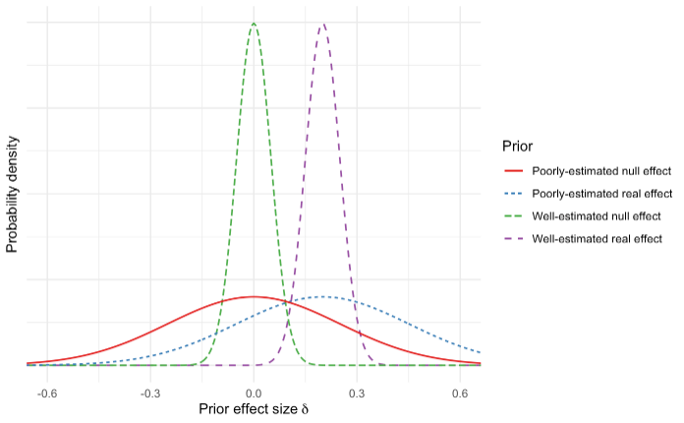

Figure 1. Density curves for the four prior probabilities.

XXX

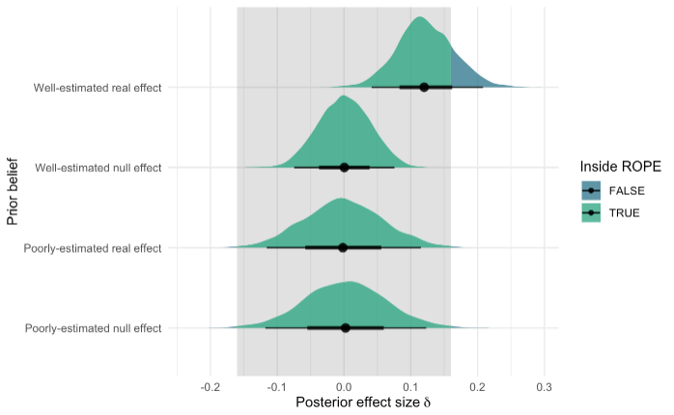

Figure 2. Posterior beliefs as a function of each prior and the data.

Results demonstrate that a posterior belief in the presence of a true effect given the data was contingent on both a) a prior belief that the effect was real but also b) relative certainty about the magnitude of the effect size.

# Notes

## Author contributions

IH conceptualized the study and analyzed the data. SH provided critical input into the design and analysis. Both authors wrote the article and approved the final submitted version of the manuscript.

## Declaration of Conflicting Interests

IH and SH declare we have no conflicts of interest with respect to the research, authorship, and/or publication of this article.

## Funding

This research was conducted with the support of Ghent University grant 01P05517 to IH and BOF16/MET_V/002 to Jan De Houwer.

# References

Bar-Anan, Y., Houwer, J. D., & Nosek, B. A. (2010). Evaluative conditioning and conscious knowledge of contingencies: A correlational investigation with large samples. *The Quarterly Journal of Experimental Psychology*, *63*(12), 2313–2335. https://doi.org/10.1080/17470211003802442

Flake, J. K., & Fried, E. I. (2019). *Measurement Schmeasurement: Questionable Measurement Practices and How to Avoid Them*. *Preprint*. https://doi.org/10.31234/osf.io/hs7wm

Flake, J. K., Pek, J., & Hehman, E. (2017). Construct Validation in Social and Personality Research: Current Practice and Recommendations. *Social Psychological and Personality Science*, *8*(4), 370–378. https://doi.org/10.1177/1948550617693063

Gawronski, B., & Walther, E. (2012). What do memory data tell us about the role of contingency awareness in evaluative conditioning? *Journal of Experimental Social Psychology*, *48*(3), 617–623. https://doi.org/10.1016/j.jesp.2012.01.002

Hussey, I., & Hughes, S. (2020). Hidden invalidity among fifteen commonly used measures in social and personality psychology. *Advances in Methods and Practices in Psychological Science*, *In Press*. https://doi.org/10.31234/osf.io/7rbfp

Jones, C. R., Fazio, R. H., & Olson, M. A. (2009). Implicit Misattribution as a Mechanism Underlying Evaluative Conditioning. *Journal of Personality and Social Psychology*, *96*(5), 933–948. https://doi.org/10.1037/a0014747

Meijer, R. R. (1994). The Number of Guttman Errors as a Simple and Powerful Person-Fit Statistic. *Applied Psychological Measurement*, *18*(4), 311–314. https://doi.org/10.1177/014662169401800402

Moran, T., Hughes, S., Hussey, I., Vadillo, M. A., Olson, M. A., Aust, F., Bading, K., Balas, R., Benedick, T., Corneille, O., Douglas, S. B., Ferguson, M. J., Fritzlen, K. A., Gast, A., Gawronski, B., Heycke, T., Högden, F., Hütter, M., Kurdi, B., … De Houwer, J. (2019). Incidental Attitude Formation via the Surveillance Task: A Pre-Registered Replication of Olson and Fazio (2001). *Psychological Science*, *Registered Replication Report Stage 1 acceptance*. https://osf.io/hs32y

Olson, M. A., & Fazio, R. H. (2001). Implicit Attitude Formation Through Classical Conditioning. *Psychological Science*, *12*(5), 413–417. https://doi.org/10.1111/1467-9280.00376

Rouder, J. N., & Morey, R. D. (2011). A Bayes factor meta-analysis of Bem’s ESP claim. *Psychonomic Bulletin & Review*, *18*(4), 682–689. https://doi.org/10.3758/s13423-011-0088-7

Valentine, J. C., Pigott, T. D., & Rothstein, H. R. (2010). How Many Studies Do You Need?: A Primer on Statistical Power for Meta-Analysis. *Journal of Educational and Behavioral Statistics*, *35*(2), 215–247. https://doi.org/10.3102/1076998609346961

Yarkoni, T. (2019). *The Generalizability Crisis*. *Preprint*. https://doi.org/10.31234/osf.io/jqw35